Auto Ticket Classification using Flow Designer

1. Project Description
Auto Ticket Classification using Flow Designer automates the classification and routing of incoming ServiceNow tickets based on ticket information such as description, category, urgency and impact.

2. Scenarios
- Software-related ticket → Software category
- Network-related ticket → Network category
- Hardware-related ticket → Hardware category
- Based on classification → appropriate support group/team

3. Technical Architecture

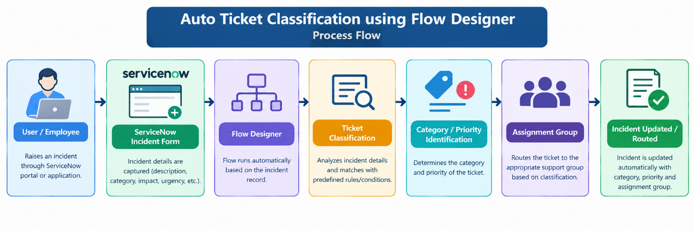

4. Pre-requisites
- ServiceNow Developer Instance
- Flow Designer knowledge
- Incident Management knowledge
- ServiceNow tables and fields
- Flow Designer actions and conditions
- Basic JavaScript knowledge (if custom scripting is used)

5. Project Workflow
Milestone 1: Requirement Analysis & Architecture
Milestone 2: Ticket Classification Logic
Milestone 3: Flow Designer Development
Milestone 4: Testing & Validation
Milestone 5: Deployment / Demonstration
Milestone 6: Conclusion

Milestone 1 – Requirement Analysis & Architecture
Activity 1.1: Identify ticket classification requirements
Activity 1.2: Identify incident fields used for classification
Activity 1.3: Design solution architecture
Activity 1.4: Configure ServiceNow Developer Instance

Milestone 2 – Classification Logic
Activity 2.1: Define ticket categories
Activity 2.2: Define classification conditions
Activity 2.3: Define assignment/routing rules
Activity 2.4: Prepare sample incident tickets

Milestone 3 – Flow Designer Development
Activity 3.1: Create Flow Designer flow
Activity 3.2: Configure incident trigger
Activity 3.3: Add classification conditions
Activity 3.4: Configure update/assignment actions
Activity 3.5: Test flow execution

Milestone 4 – Testing
Activity 4.1: Test different ticket types
Activity 4.2: Verify category classification
Activity 4.3: Verify assignment group routing
Activity 4.4: Test incorrect/unknown ticket inputs
Activity 4.5: Validate final results

Milestone 5 – Demonstration
- Create sample incident
- Show automatic flow execution
- Show classification result
- Show assignment/routing
- Verify updated incident record

Screeshots:

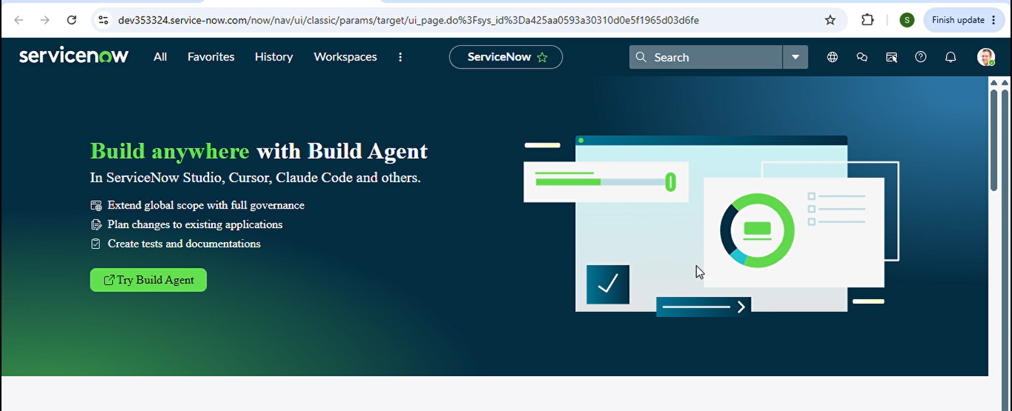

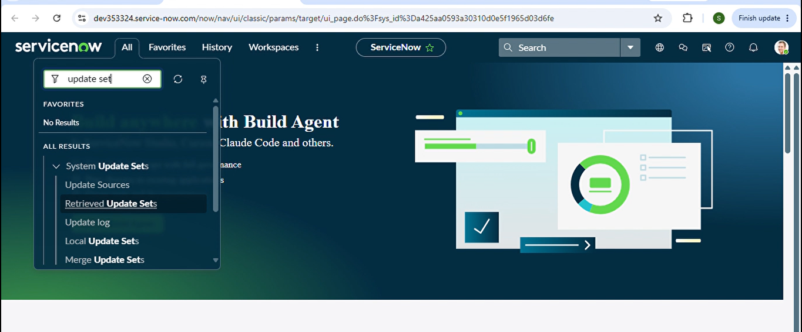

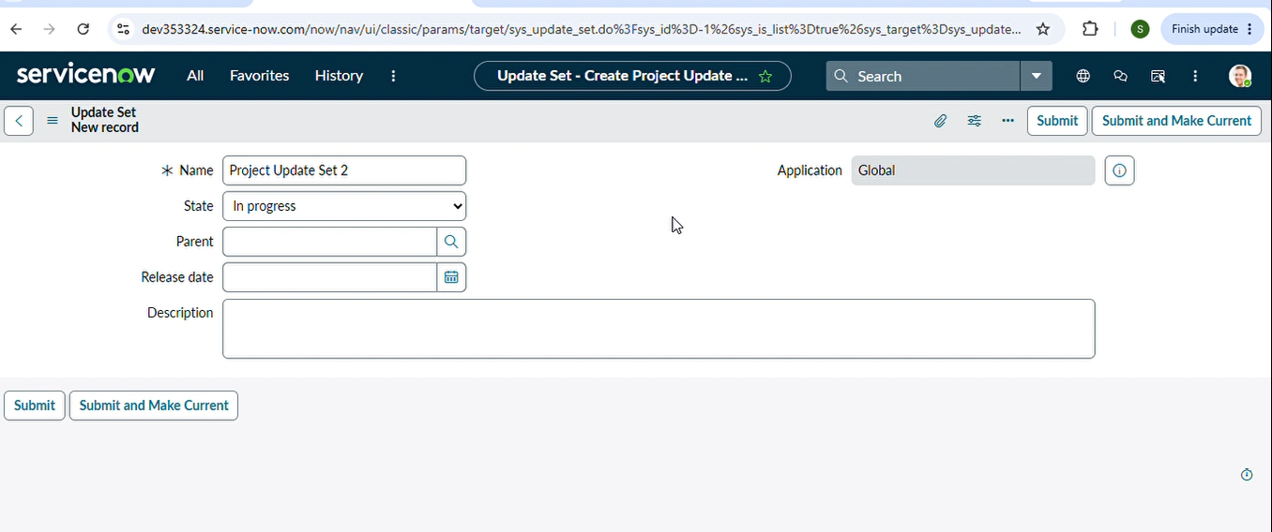

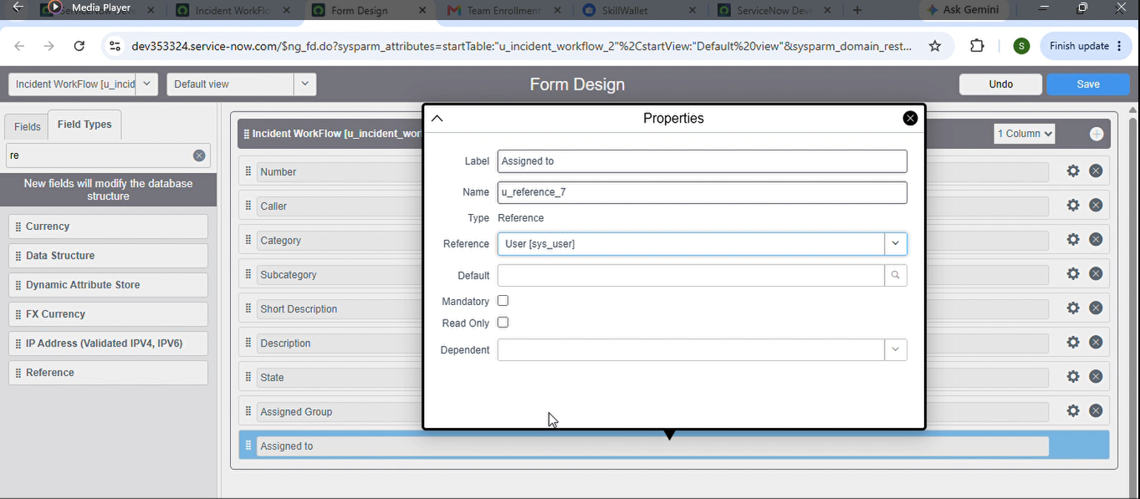

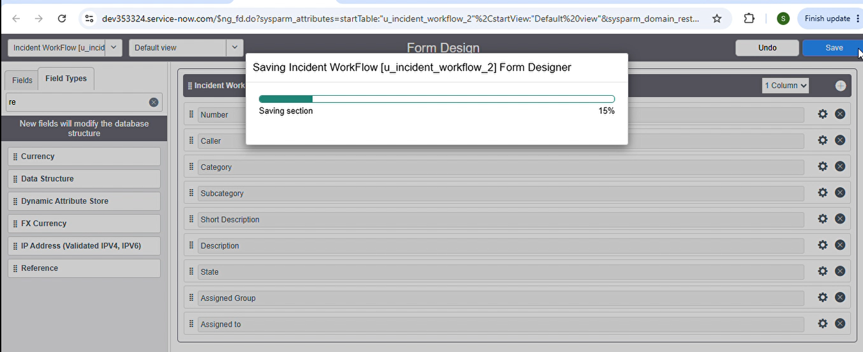

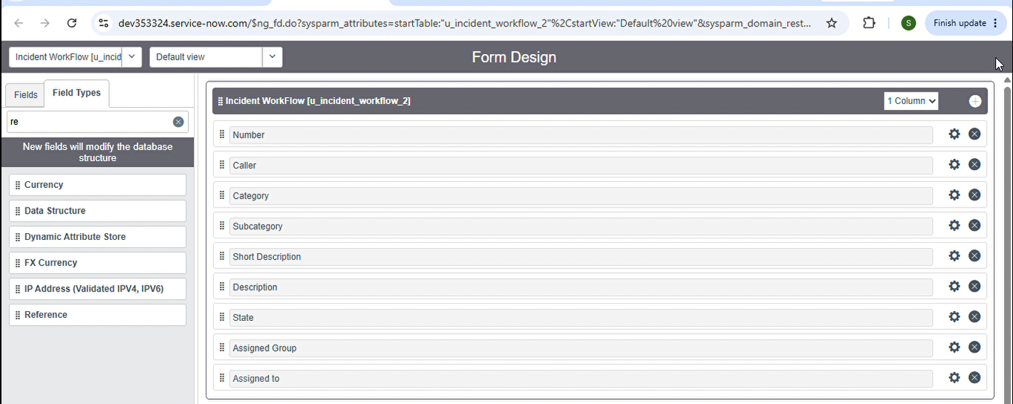

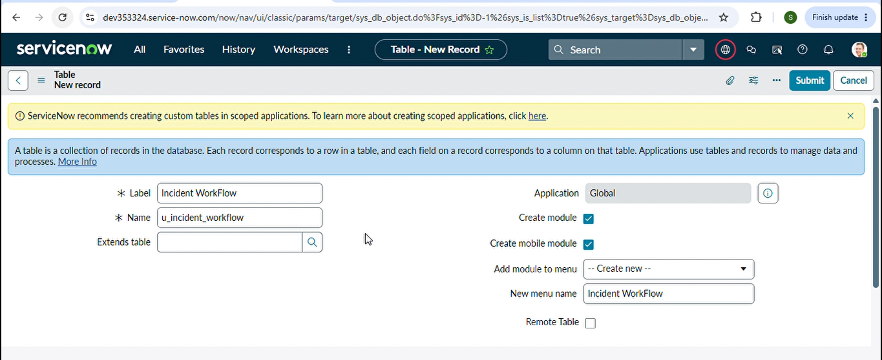

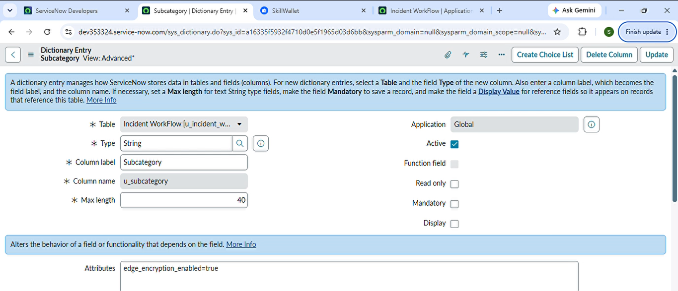

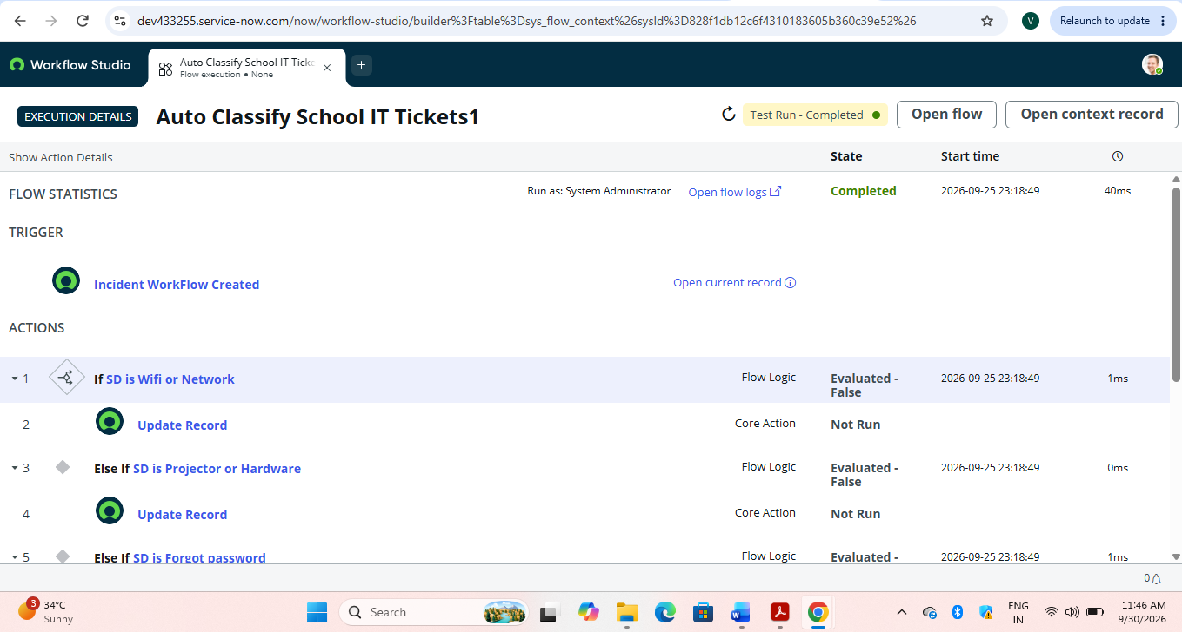

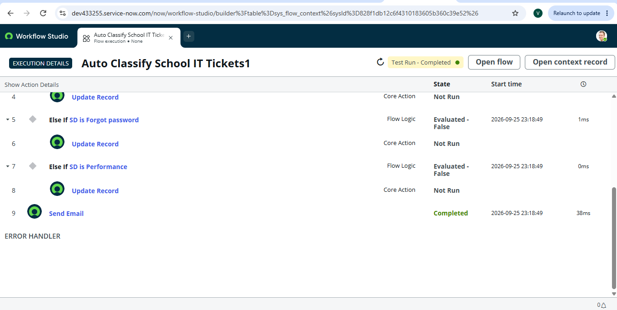

Conclusion
Auto Ticket Classification using Flow Designer helps automate the classification and routing of ServiceNow incidents. The solution reduces manual classification effort by applying predefined conditions and automatically updating the appropriate incident fields and assignment details. The project demonstrates how ServiceNow Flow Designer can be used to improve incident-management workflow automation.

